College of Arts and Sciences

Office of the Associate
and Assistant Deans

114 University Hall
230 North Oval Mall
Columbus, OH 43210

614-292-1667 Phone
asc.osu.edu

November 22, 2024

W. Randy Smith, Vice Provost
Council on Academic Affairs
Bricker Hall
CAMPUS

Dear Randy:

I am pleased to endorse the proposal by the Center for Ethnic Studies, along with the Asian American Studies Committee, to create a Graduate Interdisciplinary Specialization in Asian American Studies. The Center for Ethnic Studies will be responsible for overseeing the GIS.

The GIS addresses growing interest among graduate students in scholarship on the Asian American Experience, and provides interdisciplinary curriculum for interested students. The expected demand for this GIS will come from across the College. The GIS does not duplicate any other currently offered at Ohio State. It has the full support of the College of Arts and Sciences.

Sincerely,

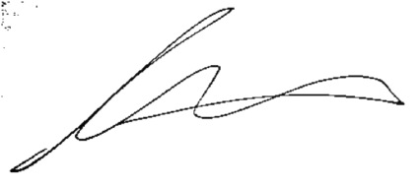

Andrew W. Martin
Associated Dean for Undergraduate Education
Professor, Department of Sociology

